**COMP 201 Coursework 1.2**

Yifan Xu

Student Number : 201377026

23 , Nov , 2018

**State Chart Diagram**

Graph 1. Hot water Handling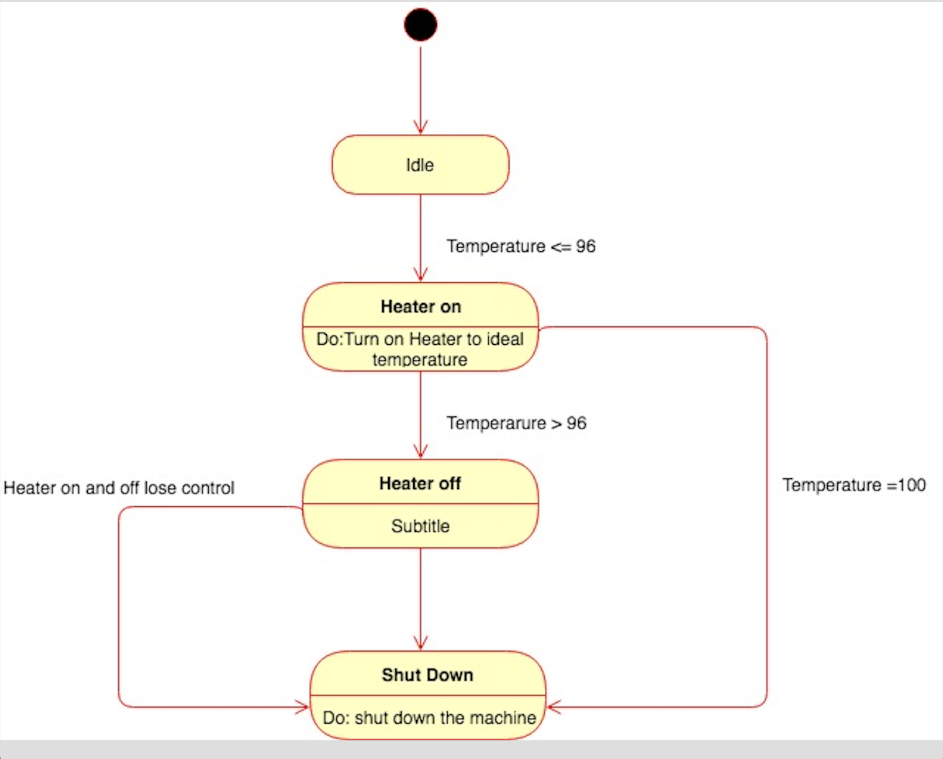

Graph 2.Coin Handling 